THE ECONOMIC WAY OF THINKING
- Everything has a cost.

OPPORTUNITY COST:

- People choose for good reasons.

- Incentives matter.

- People create economic systems to influence choice and incentives.

- People gain from voluntary trade.

- The value of goods and services is affected by people’s choices.
Societies do not have enough productive resources to satisfy everyone’s wants and needs!!

UNLIMITED WANTS & LIMITED RESOURCES

SCARCITY:

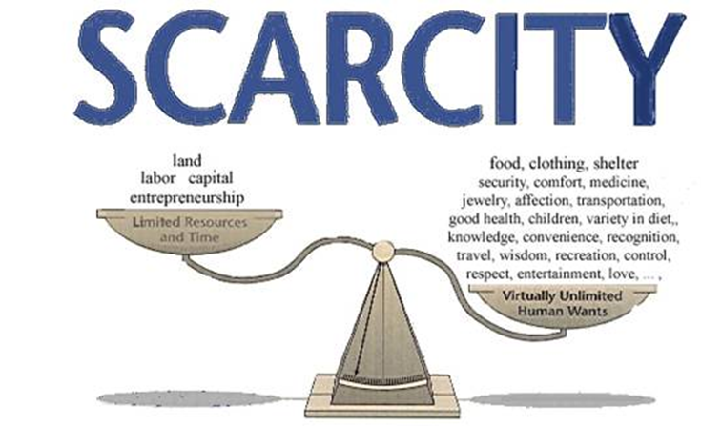

ECONOMICS IS:

