The Circular Flow of Economic Activity
Chapter 1, Section 2

The wealth an economy generates is made possible by the circular flow of economic activity. The key feature of this circular flow is the market, a location or other mechanism that allows buyers and sellers to exchange a specific product. Markets may be local, national, or global- and they can even exist in cyberspace!

FACTOR MARKETS

You participate in a factor market when you work and sell your labor to an employer.

PRODUCT MARKETS

The wages and salaries that individuals receive from businesses in the factor markets return to business in the product market.

What are the major differences between factor markets and product markets?

FACTOR MARKETS | PRODUCT MARKETS
PRODUCTIVITY and ECONOMIC GROWTH

Economic growth occurs when a nation’s total output of goods and services increases over time. This means that the circular flow becomes larger with more factors of production, goods, and services flowing in one direction and more payments in the opposite direction. Productivity is the most important factor contributing to economic growth.

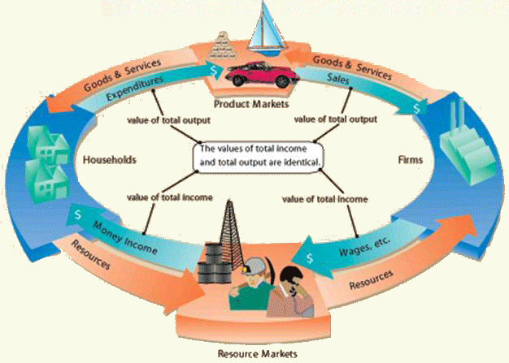

CREATE a diagram representing The Circular Flow of Economic Activity that connects you as a consumer to factor markets, product markets, businesses, and individuals.

