Section 2
Basic Economic Concepts

Economics is concerned with economic products, goods and services that are useful, relatively scarce, and transferable to others. Economic products help us satisfy our wants and needs. Because they are both scarce and useful, they command a price.
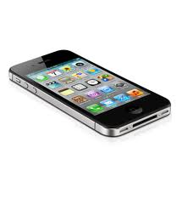
GOODS

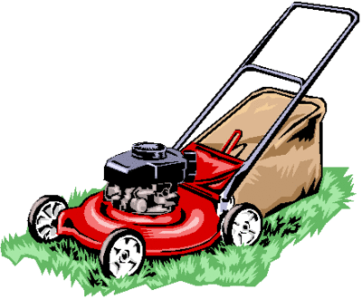
SERVICES

CONSUMERS

In economics, value refers to a worth that can be expressed in dollars and cents. Why, then, does something have value, and why are some things more valuable than others? To answer these questions, it helps to review a problem Adam Smith, a Scottish social philosopher, faced back in 1776.
Adam Smith was one of the first people to describe how markets work. He observed that some necessitates, such as water, had very low monetary value. On the other hand, some nonnecessities, such as diamonds, had a very high value. Smith called this contradiction the Paradox of Value. Economists knew that scarcity was necessary for something to have value. Still, scarcity by itself could not fully explain how value is determined.

UTILITY

VALUE

WEALTH

While goods are counted as wealth, services are not, because they are intangible. However, this does not mean that services are not useful or valuable. Indeed, when Adam Smith published his famous book The Wealth of Nations in 1776, he was referring specifically to the abilities and skills of a nation’s people as the source of it’s wealth. For Smith, if a country’s material possessions were taken away, it’s people, through their efforts and skills, could restore these possessions. On the other hand, if a country’s people were taken away, it’s wealth would deteriorate.

CONSUMER GOOD | Good intended for final use by consumers rather than businesses.
DURABLE GOOD | A good that lasts for at least 3 years when uses regularly
NonDURABLE GOOD | A good that wears out or lasts for fewer than three years when used regularly

