Chapter 11
Economic Challenges
SECTION 1: Unemployment

Unemployment threatens the security and well-being of Americans and their families every day. People who want to work but are unable to find jobs face many hardships. They may experience low self-esteem and other personal problems. They may be unable to afford many of the goods and services they need and may even lose their homes and belongings.
Individuals can be greatly affected by unemployment. At the same time, however, high rates of unemployment also hurt the economy as a whole. The nation loses the goods and services that the unemployed would produce if they were working. Businesses lose sales because the unemployed cannot buy as many products. More over, the governement must decide how to and to what extent to support the unemployed and their dependents.
- How many workers are unemployed?
- How long have they been jobless?
- How does unemployment differ for specific industries and geographic regions?
To answer these questions, the U.S. Census Bureau conducts a monthly study called the Current Population Study.

UNEMPLOYMENT RATE:

DISCOURAGED WORKERS:

UNDEREMPLOYED:

FULL EMPLOYMENT:

TYPES OF UNEMPLOYMENT
Frictional Unemployment | Structural Unemployment
Seasonal Unemployment | Cyclical Unemployment

- Does the employment rate accurately represent the number of people who are unemployed? Explain your answer.

- Give an example NOT mentioned in class that represents each of the major types of unemployment.

- Frictional

- Structural

- Seasonal

- Cyclical

Is a Jobless Recovery the New Normal?
In the most recent (2008-2009) and the previous (2001) recessions, it took a significant length of time to recreate the number of jobs lost during the downturn. In both instances, the economy began to grow without increasing jobs at a similar rate. - what some call a "jobless recovery."
Historically, at the end of a recession, with the economy in the upward phase of the business cycle, companies have hired back unemployed workers. In these cases, where the recession was in a typical business cycle, the renewed demand for goods and services motivated employers to hire. And, typically, the growth of jobs fell in line with the growth in output in a more labor-intensive system.
Today, growth seems to more easily happen without that same pattern of rehiring. Maybe companies are reluctant to hire more workers when the future is uncertain. Maybe companies are taking advantage of the recession to adjust how they do things. Can they produce more with fewer workers? Maybe improvements in technology have created a structural change in the economy and the workforce has to change to fit that structure. In any case, employment growth through 2011 lagged the GDP growth of the economy. The U.S. unemployment rate has remained at an unacceptably high level.
Take a look at the February 3, 2012, BLS "Employment Situation - January 2012" announcement to learn more about current labor market conditions and the recovery.
Bureau of Labor Statistics: The Employment Situation – January ,2012
Released February 3, 2012
"Total nonfarm payroll employment rose by 243,000 in January, and the unemployment rate decreased to 8.3 percent, the U.S. Bureau of Labor Statistics reported today. Job growth was widespread in the private sector, with large employment gains in professional and business services, leisure and hospitality, and manufacturing. Government employment changed little over the month."
The consensus is that it takes 125,000 to 150,000 new jobs each month just to accommodate growth of the labor force. If that is accurate, a gain of 243,000 jobs means the economy is finally catching up. In January, a total of 847,000 more people were employed and 339,000 fewer people were unemployed. The labor force grew by 508,000, despite the fact that over a million people joined the ranks of those "not in the labor force." All of this adds up to the 8.3 percent unemployment rate reported for January, 2012.
Figure 1, below, shows the key U.S. labor market data for December, 2011, and January, 2012.
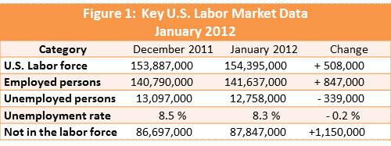
"The unemployment rate declined by 0.2 percentage point in January to 8.3 percent; the rate has fallen by 0.8 point since August. (See table A-1.) The number of unemployed persons declined to 12.8 million in January."
Sounds like good news, right? But, 12.8 million unemployed and an 8.3 percent unemployment rate are still almost twice the numbers that are considered to be "normal." The U.S. unemployment rate prior to the beginning of the 2008-2009 recession was 4.7 percent (November, 2007).
Figure 2, below, shows the monthly U.S. unemployment rates since the year 2000. The rate was 4.7 percent prior to the beginning of the recession in December 2007.
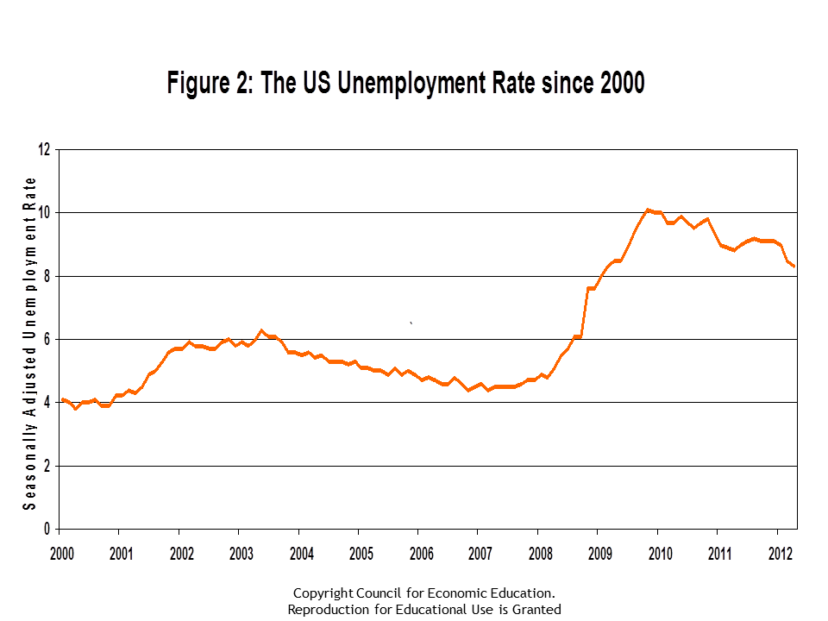
How can unemployment remain high if there are so many new jobs in the economy? Remember, the unemployment rate is determined by two factors:
1) the size of the labor force
2) the number of unemployed persons.

Also remember, The number of employed persons plus the number of unemployed persons equals the labor force. In January, the labor force grew by 508,000.
In the past twelve months, since January, 2012, the U.S. economy has created 1,750,000 jobs, but over 13,000,000 Americans remain unemployed.

CONCLUSION
The U.S. economy created 243,000 new jobs in January, 2012. Maybe a "jobless recovery" is not the new normal. It is not good practice to identify a trend based on one or two months' data, nut the January employment data was welcomed news to many.
Job creation since the beginning of the recovery has been erratic - a few months of good job growth and then a few months of slow job growth, etc. Both the unemployment rate and number of unemployed are back to the level of February 2009, but well above the levels of November 2007.
Job growth in construction and manufacturing were strong in December 2011 and January 2012. Was it the strength of the economy or the result of warmer-than-usual weather in much of the country?
[Teacher Note: Ask students: What do you think will be the best sign that the economy is really recovering?]
The 2008-2009 recession was longer and more widespread than any recession since the Great Depression of the 1930s. Job growth in this recovery has been slower than other periods, but may have turned the corner. Keep an eye on job growth over the next few months to see if there is a solid growth trend.

WOMEN IN THE LABOR FORCE
The past several decades have been marked by notable
changes in women’s labor force activities. Women’s
labor force participation is significantly higher today
than it was in the 1970s, particularly among women with
children, and a larger share of women work full time and
year round than in past decades. In addition, women have
increasingly attained higher levels of education: among
women aged 25 to 64 who are in the labor force, the proportion
with a college degree roughly tripled from 1970 to
2008. Women’s earnings as a proportion of men’s earnings
also have grown over time. In 1979, women working full
time earned 62 percent of what men did; in 2008, women’s
earnings were 80 percent of men’s.

How do you think these changes in the status of women have affected our society, our economy, and our lives?

