Bonds and Futures
Why buy Bonds??

CORPORTATE BONDS | GOVERNMENT BONDS

Treasury Bill | Treasury Note | Treasury Bond

Why buy Futures??

Ag Products | Industrial Goods
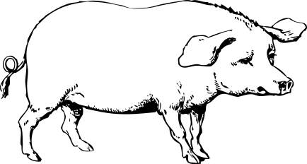
HOGS?

